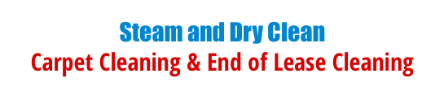

Have a stain on your carpet?
Need a pet stain treatment that works the first time?

Steam and Dryclean have just the treatment included in our pet stain treatment package.

Red coupon code 846370

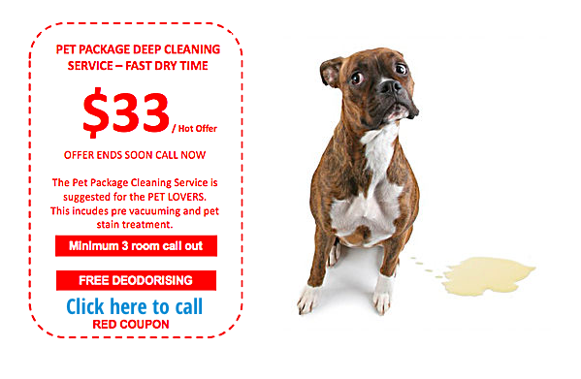

Call Now 0406 846 370

